

**American International University- Bangladesh**

**CSC 3222: Web Technologies**

**CO1.1 and CO2.1 Evaluation**

**Project Report**

**Summer 18-19**

**Project Title: AIUB Social Hub**

**Section: B**

|  |  |
| --- | --- |
| Student Name | Student Id |
| Kutub Uddin , Khaja | **17-33108-1** |
| Fahim, Imtiaz Ahmed | **17-33088-1** |
| Hanif, Md. | **17-33673-1** |
| Chowdhury , Mahfuzul Karim | **17-33669-1** |

**Introduction:**

The main goal of this project is to give AIUB students a common platform. Where they can share their study contents, help each other. They also can communicate with each other via messaging. AIUB Social Hub will stablish a bond among all the AIUBians. We wanted to make this project because we have felt the necessity of a common platform where we can share our idea with each other. This is one of the major reason behind this project. There are also some minor reason like there are no social hub for AIUB students whereas other university do have common platform to communicate with each other.

**Background Study**

Before making of this project, we have studied some social platform website. The website we have studied is given below.

1. Facebook: Everyone knows that Facebook is one of the biggest social platform for everyone. It has millions of users. Any user can share photo, video, events. Anyone can post their thoughts. So it Facebook was one of the main reason behind the project.

Reference: [www.facebook.com](http://www.facebook.com)

1. Twitter: Twitter is another great social platform for tweeting or sharing. We also studied twitter to get idea of sharing or twitting

Reference: [www.twitter.com](http://www.twitter.com)

**Requirement Analysis:**

1. **User Category:**

There are 2-types of Users here. They are:

* Admin
* General User

1. **Feature List:**

In this project the admin has the following features:

* Admin can see all public post
* Admin can comment on posts
* Admin can ban user
* Admin can warn user
* Admin can access any profile

In this project the general user has the following features:

* General user can post anything
* General user can comment on other post
* General user can message each others
* General user can like other post
* General user can update their information
* General user can send and accept friend request
* General user can search other
* General user can see friends information

**Design:**

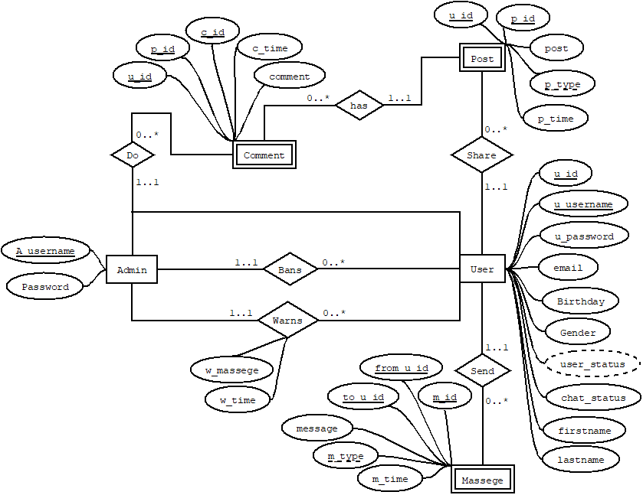

**Tools Used:**

To develop this project, we have used the following:

• PHPstorm

• Visual Studio Codes

• XAMPP

• Sublime

• Dia

**System Images against the Specification:**

* **Login and Registration**: Here user can create their account. User and admin can login from here.

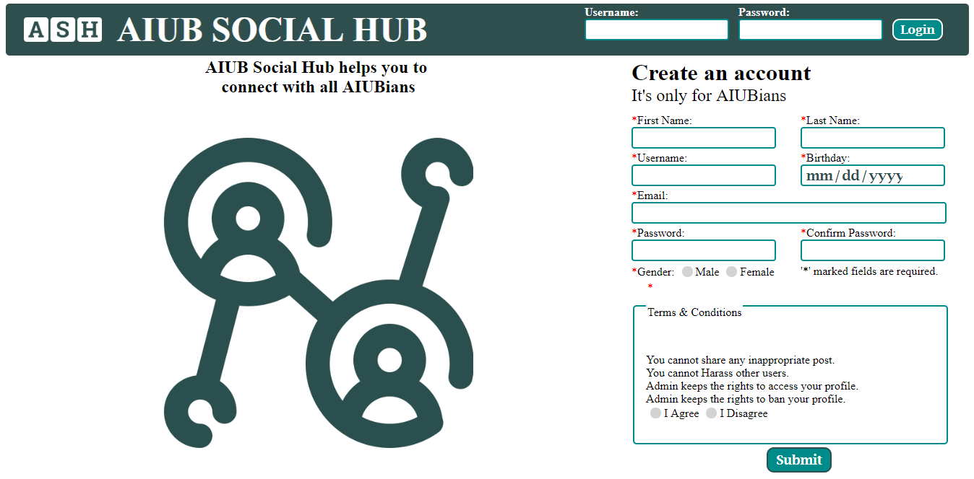

* **User Home**: Here user can see the posts of other users. User also can post from here.

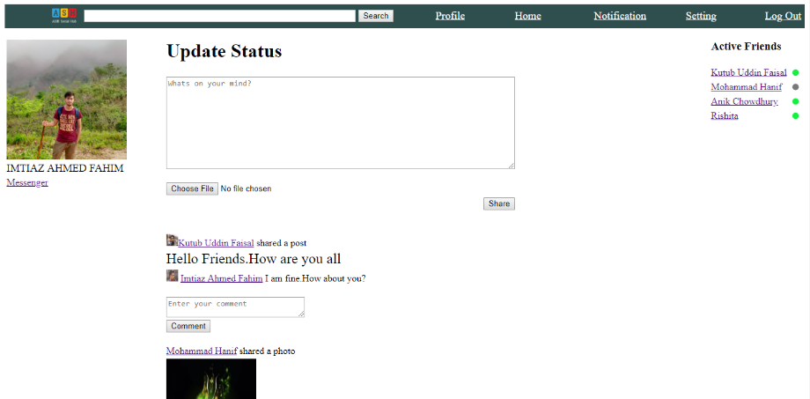

* 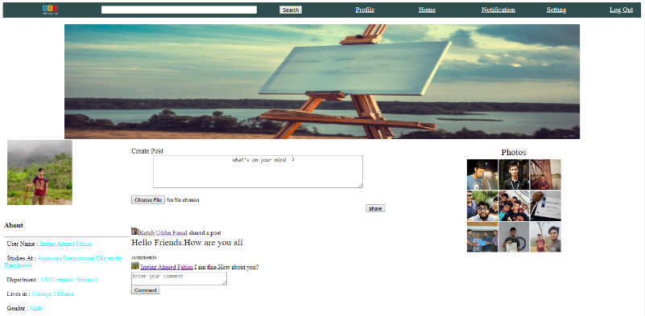**User Profile**: Here user can the timeline of his posts.
* 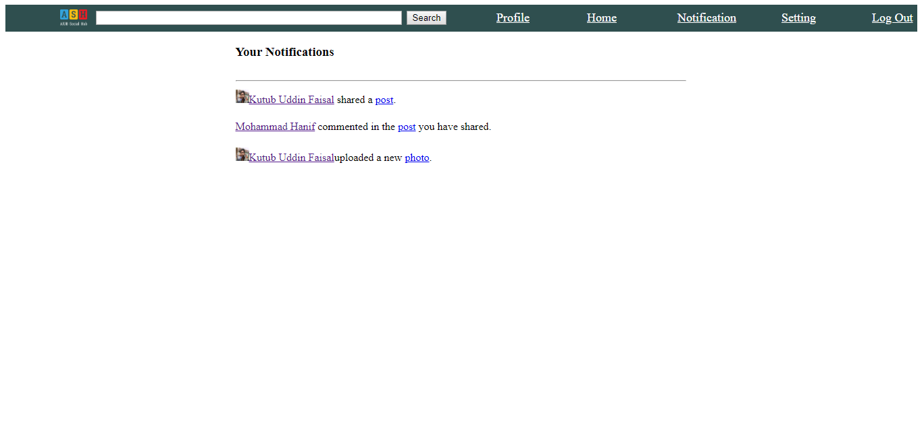**Notification**: Here user can see the notifications.
* 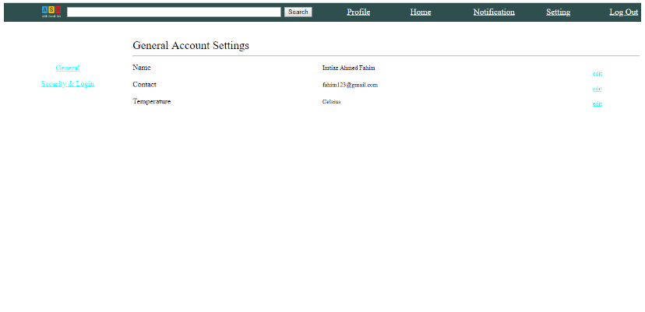**Settings**: Here user can change the settings and update his profile information.
* 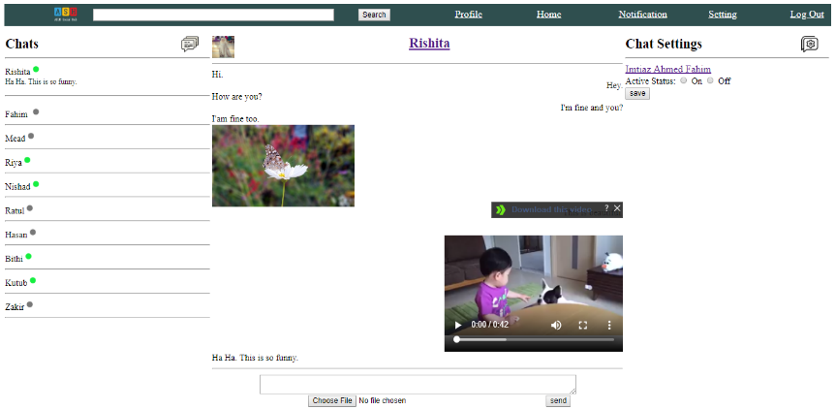**Messenger**: Here users can chat with each others and send files.
* 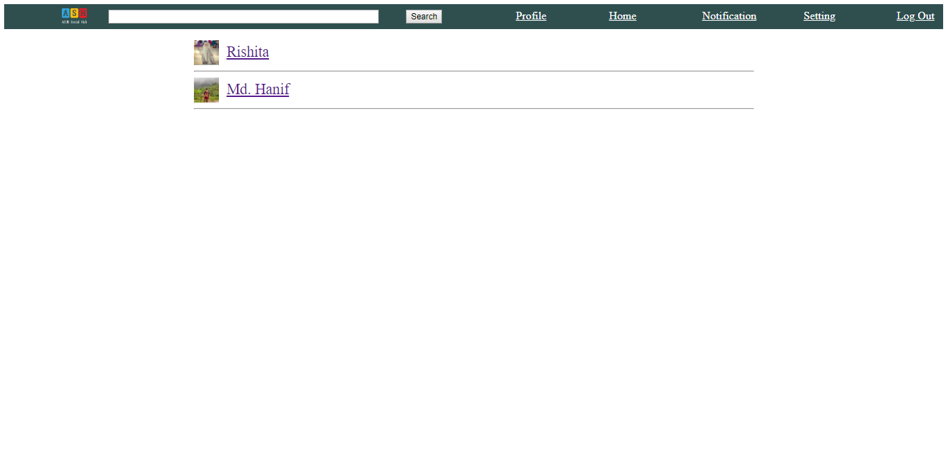**Friends**: Here user’s can see their friends list.
* 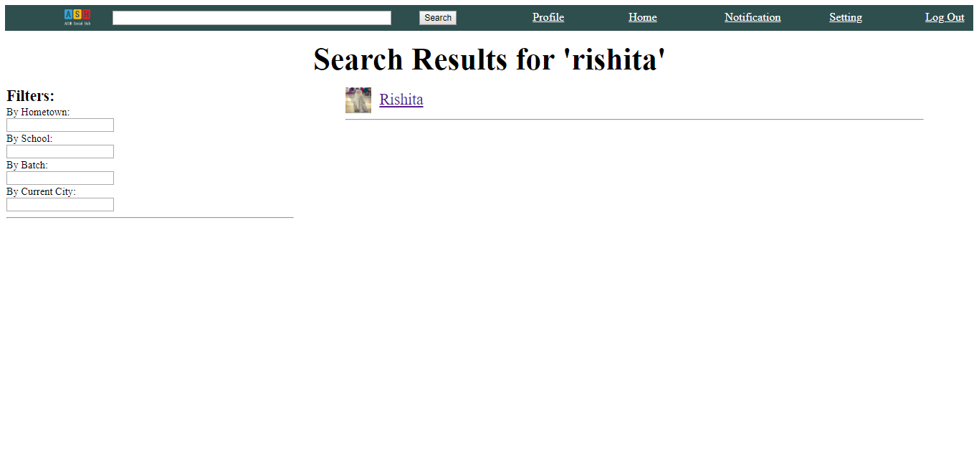**Advance search and search result**: Here user can his search result and can perform advance search as well.
* 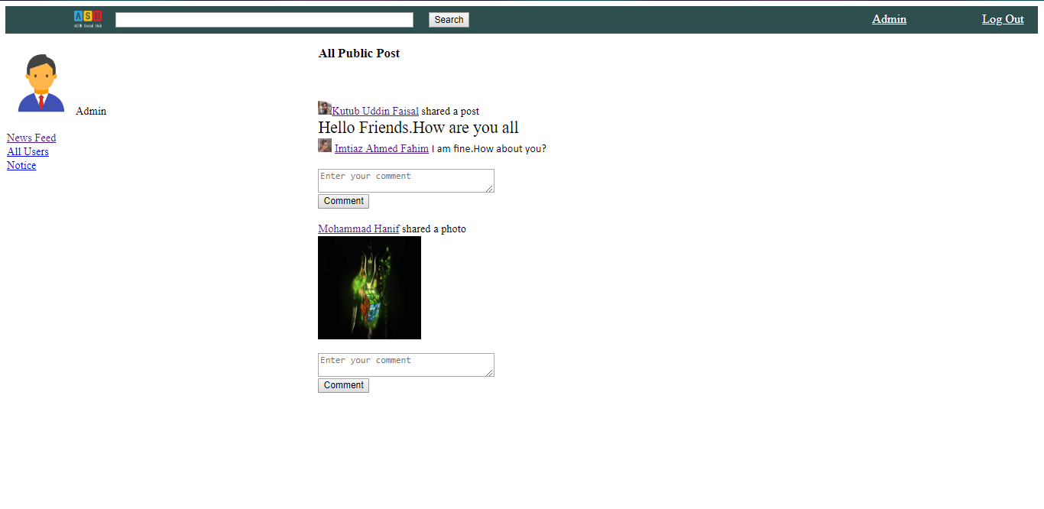**Admin home**: Here admin can see the posts of all users in the system.
* 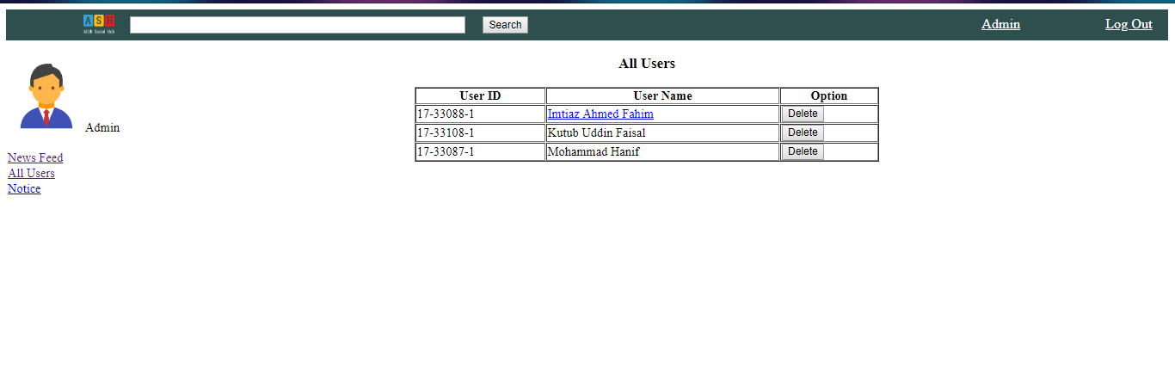**Users list**: Here admin can see the list of all users and also can ban user profile.
* 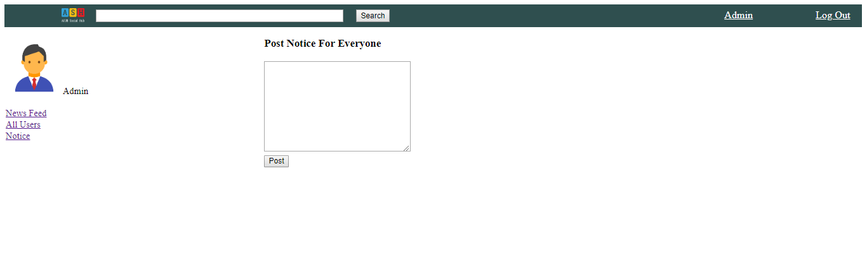**Notice**: Here admin can write warning message and warn user.

**Impact of this Project:**

AIUB Social Hub usage has been associated with positive impacts to different aspects   
of people’s lives, including positive impacts, such as improving relationships between friends.   
  
The Social Networking in general and AIUB Social Hub in particular offers significant advantages for its   
users. For example, sharing and collecting information, communication, and entertainment. Usually, the  
information on the Internet is free of cost and is available 24 hours a day.   
In addition, the AIUB Social Hub provides its users with the latest news of the AIUB.  
Thus, AIUB Social Hub users can read news articles or opinions about world events,   
and share this information and their own thoughts with others like themselves.  
  
People of AIUB can now quickly communicate with each other through the AIUB Social Hub using a range of   
applications: chatting, Wall post, and helps to download some books.

**Limitations and Possible Future Improvements:**

The limitations of AIUB Social Hub are there is no group chatting system, no privacy for users posts. Users cannot create a group or pages in AIUB Social Hub. These are available in many other social network sites. Currently, AIUB Social Hub is hosted in localhost.

In future we may add features like group chatting, privacy, creating groups and pages etc. We may host the project in web host. We may add some extra security features like verification of a user during registration if the user is a AIUB student or not by matching the username in AIUB student database.

|  |  |  |  |  |  |
| --- | --- | --- | --- | --- | --- |
| **CO1.1 and CO2.1 Evaluation: Project Report Evaluation** | | | | | |
| **Project Proposal**  **(5)** | **Background**  **Study**  **(5)** | **Requirement Analysis**  **(5)** | **Entity**  **Diagram**  **(5)** | **System Images**  **against the**  **Specification (5)** | **Total (25)** |
|  |  |  |  |  |  |
|  | | | | | |